Executive Summary
As reported by a well-known financial adviser, the winning numbers in a city's pick-five lottery seem to be a result of some kind of random process. For dramatic effect, the winning lottery numbers are generated and displayed on ping-pong balls in front of the audience during a live televised drawing. The numbers are then rolled out one by one in front of the crowd during a live televised drawing. Those whose numbers match all five of the numbers drawn are awarded a considerable amount of money if their numbers are drawn. Those who match fewer numbers earn less money than players who match a greater number of numbers win more money. Of course, the great majority of participants do not match any numbers and, as a result, earn nothing in exchange for their participation, other than a little amusement. However, according to Bank of America, the data are repeating their previous patterns. The bank's claim is substantiated by the use of the pivot table approach, which was implemented. It is necessary to compute averages across three cities and examine the frequency of recurrence in order to assess the bank's claim and find the repeated numbers.

Contents
Executive Summary 1
Introduction 3
Findings and Discussions 3
Conclusions 9
Recommendations 9
References 11

Introduction

Today's world run on technology. World's top most organizations rely mainly on the use of technological innovations to achieve their goals. Lottery is found around the world and lotteries are considered a fair system by most of the people. To analyse this, we have made use of pivot table which helped to examine the data of lotteries of three cities. Pivot table provides user-friendly features and provides valuable insights to work on large amount of data. With help of frequencies, we examine the repeating order of lottery numbers. Frequency method help to have a glance of the complete data in an easy way. It represents raw data in organized format and helps to identify repeating lottery numbers conveniently. This report analysis the bank’s claim on city lotteries stating that their system is not trustworthy. This makes lottery operators in big difficulty because people will lose trust if the claim by the bank is proved correct.

Findings and Discussions
Developing information system solutions to the business problems can help a lot to tackle with the emerging difficulties. Various strategies of information technology are adopted to analyse the business needs. Real-world organization uses these technologies to compete in the current scenario. Lotteries are one of the systems that make use of this technology which has taken it to a lot higher level. But one problem that can be often seen relates to the verification of the lottery system. It is chiefly believed by the public that in lottery system the winning numbers are chosen randomly. Therefore, it is considered as a fair system of selecting a winner. For example, in a random selection each number I.e., 1 is as likely to be selected as number 23 or number 50 have same possibility of appearing as number 1 or 23. But the Bank states the opposite. According to them some numbers in the lottery have more chance of winning than the others. This makes a big trouble for the lottery operators as many of the people are likely to believe in the Bank’s advice.
This report analyses the authentication of the method employed by the lottery operators. This will be done by taking the data from the three different cities having 706 winning combinations.
In order to evaluate this issue five questions relating to the problem, based on the data provided of the three cities, are examined.
 | City A average | City B average | City C average
Ball 1 (Average) | 28.82011331 | 27.82011331 | 27.92634561
Ball 2 (Average) | 28.82011331 | 27.82011331 | 27.92634561
Ball 3 (average) | 28.82011331 | 27.82011331 | 27.92634561
Ball 4 (Average) | 28.82011331 | 27.82011331 | 27.92634561
Ball 5 (Average) | 28.82011331 | 27.82011331 | 27.92634561

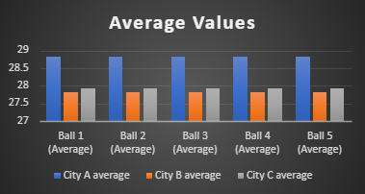

In order to clarify that the numbers appearing in the lottery system are non-repeating and random the average of each ball in three different cities is examined. This lottery indicates the use 56 different numbers/integers. This makes the average of 28 or 29. The average displayed by each city varies but is quite closer to each other. On ball 1 the City A displays the average of 28.82011331, while City B has an average of 27.82011331, and City C represents an average of 27.92634561. Looking at the ball 2 City A has an average of 28.82011331, City B has 27.82011331, City C has 27.92634561. In ball 3 City A has 28.82011331, City B has 27.82011331, City C has 27.92634561 average. The ball 4 holds 28.82011331 average in City A, 27.82011331 average in City B and 27.92634561 average in City C. the average rate of ball 5 in City A is 28.82011331, City B is 27.82011331 and City C is 27.92634561.
The overall average of each ball in each city is around 27 to 29. As there were 56 integers which makes their average of 28 or 29. So, this research shows that the numbers appearing in the lottery system are chosen randomly and are non-repeating. This makes it clear that the method employed by the lottery operators is fair and the algorithm produces unusual ball values.
City A | Numbers | Frequencies
Most Frequent | 43 | 80
2nd Most Frequent | 6 | 80
3rd Most Frequent | 41 | 76
4th Most Frequent | 20 | 76
5th Most Frequent | 34 | 74

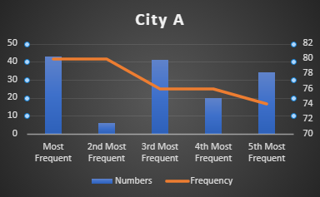

City B | Numbers | Frequencies
Most Frequent | 31 | 82
2nd Most Frequent | 20 | 80
3rd Most Frequent | 14 | 80
4th Most Frequent | 13 | 80
5th Most Frequent | 42 | 79

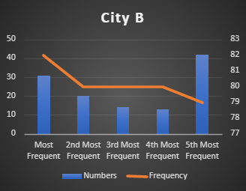

City C | Numbers | Frequencies
Most Frequent | 53 | 85
2nd Most Frequent | 5 | 82
3rd Most Frequent | 22 | 80
4th Most Frequent | 31 | 75
5th Most Frequent | 14 | 75
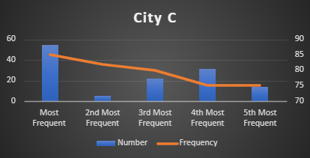

The bank claims that the lottery system is not fair and there are few numbers which are more likely to appear than the other. That's the reason some people win repeatedly. This creates a big hustle between people and they are advised to avoid a lottery that has a system of choosing the winning numbers non randomly. According to bank there are few numbers which likely to appear more. These includes number 48, 36, 53, 12 and 51.
Although, by examining the above tables and graphs we can see that none of the numbers mentioned by the bank has more appearance that the other. Looking at number 48, we can infer that it has a very low frequency in all the three cities. Similarly, if we look at number 36 it also has the same ratio as number 48. The number 53 also does not show an appearance in all the three cities and the same is applied to rest two numbers mentioned by the bank I.e., 12 and 51.

On the account of this, it can be concluded that the bank's statement about the repetitive numbers proved to be wrong as none of the five number appeared in all the three cities.
 | City A |  | City B |  | City C
 | Numbers | Frequencies | Numbers | Frequencies | Numbers | Frequencies
Most Frequent | 43 | 80 | 31 | 82 | 53 | 85
2nd Most Frequent | 6 | 80 | 20 | 80 | 5 | 82
3rd Most Frequent | 41 | 76 | 14 | 80 | 22 | 80
4th Most Frequent | 20 | 76 | 13 | 80 | 31 | 75
5th Most Frequent | 34 | 74 | 42 | 79 | 14 | 75

In accordance with the above table, the top five values in each differs from each other. Each city has its own top five numbers having varying frequencies. The most repetitive number in City A is 43, while in City B is 33 and City C is 51. Each number has different frequency rate I.e., 80, 82 and 85 respectively which shows that they have diverse chances of appearance.
Likewise, the top five values in the city’s does not go with the top five values in the three cities.
 | Number | Frequency | City
Most freq | 52 | 85 | C
2nd most freq | 5 | 85 | C
3rd most freq | 31 | 82 | B
4th most freq | 14 | 80 | B
5th most freq | 13 | 80 | B

Each city has its own unique numbers. The table above indicates that each city has different ball values with different frequencies. The top five numbers appearing more frequently are from City B and City C. This shows that the algorithm does not favours any ball value. They are distinctive to each city and does not repeat across the cities.
As with the advancement in technology more technological methods are used for business. The lottery system is also using a software which is based on random number picking technique. These organizations are working with accuracy with the help of these software. But as the bank holds an important part of the state its assertions cannot be denounced. But with the aforementioned statistics it is to a large extent evinced that lottery operators work with the method of random number picking approach. This analysis has expelled the doubts regarding bank's claim.

Conclusions
The lottery is found chiefly around the globe and in the present times lottery systems are found to be most successful. Most of the lottery players play with a proper plan which increase their chances of success. Some of the people believe that it is widely based on luck while other tend to believe more on the strategies of the game. This requires choosing a lottery system that best suits you because most of the lottery winners primarily rely on lottery systems. There are different types of lottery systems including lottery wheeling, lottery syndicates which instead of a single person rather involves a group of people for the single ticket and the delta system which is considered one of the most successful systems.
As the prize money won in the lottery ranges to hundreds and thousands of dollars a lot of people buy lottery tickets and participate to win huge rewards. With the advancement in technology results in the increase of online network around the globe. This also led to the emergence of online lottery system. Online lotteries are mostly carried by private businesses rather than government. They are more convenient as you can participate in it all from the ease of your home. This also creates wider pool of opportunities for participating in large number of lotteries including both national and international games. These online lotteries often involve a lottery agent that act as a middleman for games like EuroJackpot and PowerBall. Online lottery often charges higher amount of money than the original ticket price. This is done by the middlemen who set their commission as well. But this saves your from travelling a long distance and are more convenient.
To conclude, it is proved that number appearing in city lotteries are non-repeating and the bank's claim is proved wrong. City lotteries are reliable and trustworthy and their system is entirely fair and people can participate in them expelling all the doubts and win exciting prices.

Recommendations
People all throughout the globe have benefited from major new technology for gathering and processing information. Because information systems enabled more human activities, they had a huge influence on society. With these platforms, people could make and keep new, often more satisfying relationships, organisations changed in structure and composition, products bought changed in kind, and work altered. Information and knowledge are becoming vital economic resources. However, dependence on information technology has introduced new hazards.
By effectively documenting and managing the necessary information, as well as fixing matches, a lottery management information system ensures that the club or organisation can achieve all of its objectives. Businesses, for example, may continually improve their environmental performance by utilising an environmental management system. Accounting (assigning personal responsibility) and a deadline for tasks to be performed are expected to result in an upward cycle of continual improvement. Depending on the demands of the business, a lottery management information system may be designed in-house or by an external source. This can be achieved by subcontracting certain components or the entire system.

References
Combs, K., Kim, J. and Spry, J., 2008. The relative regressivity of seven lottery games. Applied Economics, 40(1), pp.35-39.
Lotterycritic 2021. How Does Online Lottery Work?. [online] Available at: <https://www.lotterycritic.com/news/how-do-online-lotteries-work/> [Accessed 15 January 2022].
McKean, M., 2021. Lottery System 2022 | Lottery winning systems that really work. [online] Captain Gambling. Available at: <https://www.captaingambling.com/lottery/system/> [Accessed 15 January 2022].
Qsstudy.com. n.d. How can you develop information systems solutions to business problems? - QS Study. [online] Available at: <https://qsstudy.com/how-can-you-develop-information-systems-solutions-to-business-problems/> [Accessed 15 January 2022].

